***IMPORTANT Re-MAP the Reports to Point to the Database that the Reports will be run against***

Go to The TMM desktop application. Under User Tables🡪 Report Menus –TMM Web Title Reports 🡪 Content Services. Click New Entry.

Enter the below information to setup the Content Services Reports.

1. Description is --  **Step 1: Execute Verification Procedure**
   1. The above description points to the following Report Name -- CS_Preflight.rpt
2. Description is -- **Step 2: Verification Messages Report**
   1. The above description points to the following Report Name --CS_Preflight__Detailed_BHP_new.rpt
3. Description is -- **CS Trading Partner Report**
   1. The above description points to the following report Name -- Content_Services_Trading_Partner.rpt

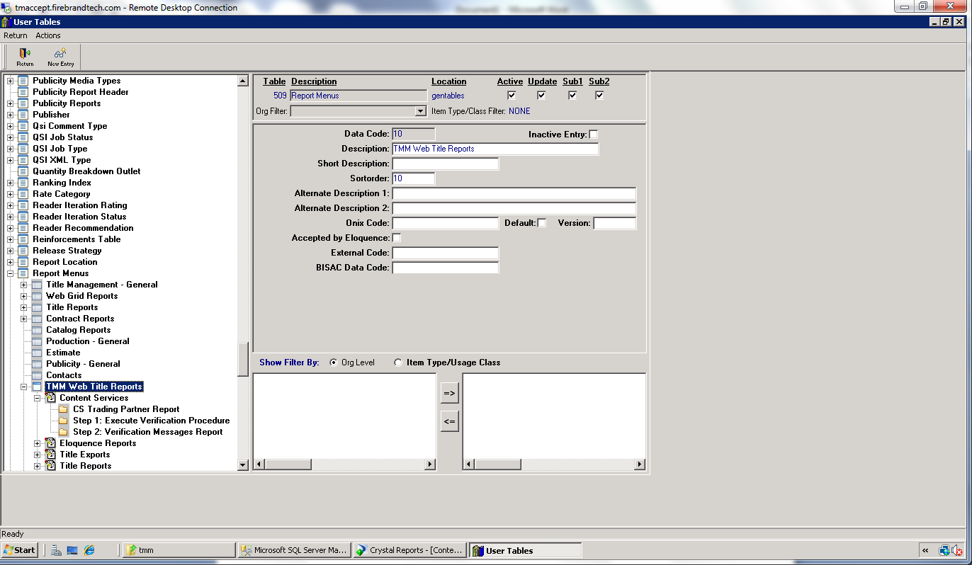

A screen shot of 1 through 3 are below:

1.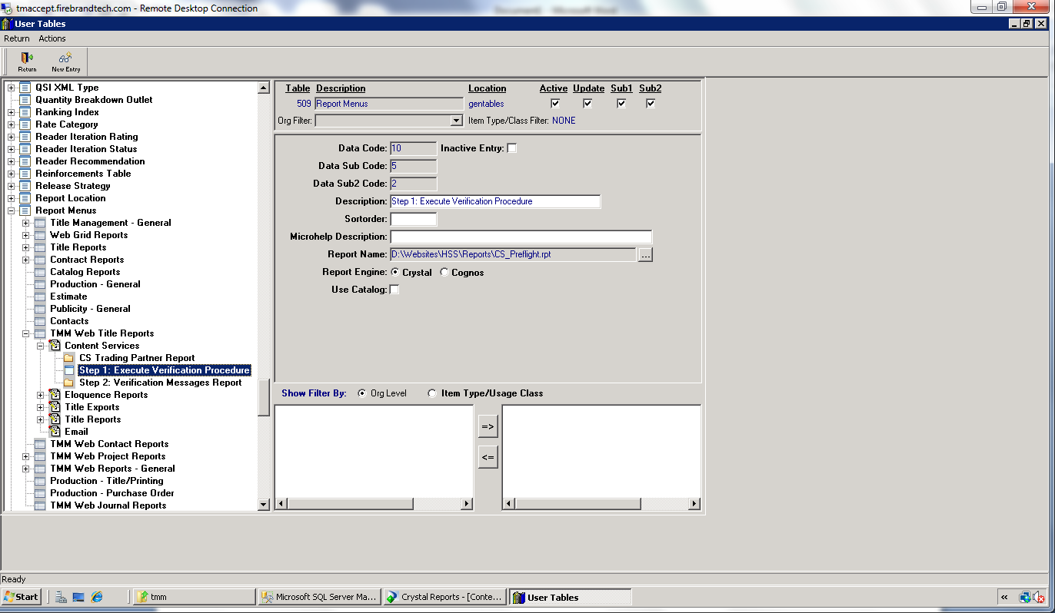

2.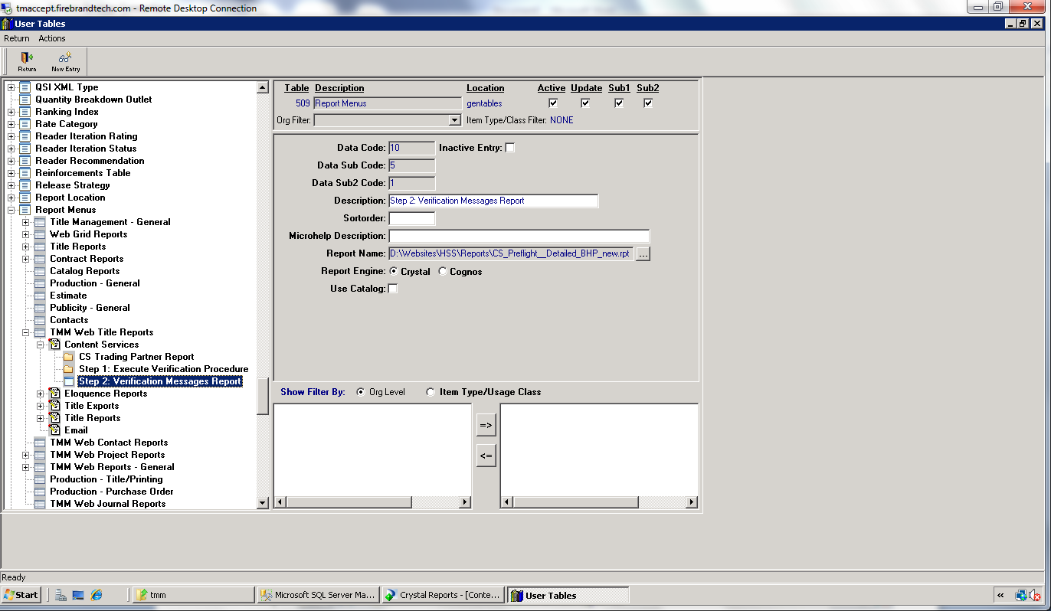

3.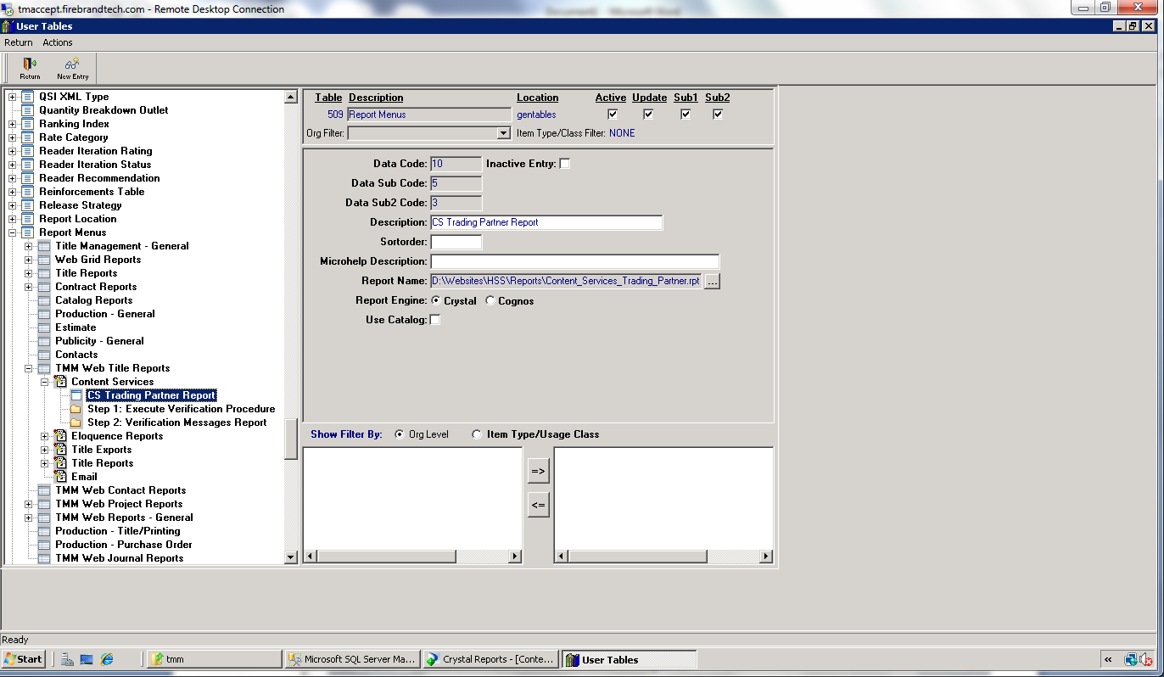

The three reports for the contents services are as follows:

1. CS_Preflight.rpt
2. CS_Preflight__Detailed_BHP_new.rpt
3. Content_Services_Trading_Partner.rpt

The following stored procedures and Functions are used for the reports:

**FUNCTIONS**

1. Rpt_get_title_task
2. Get_format
3. Get_title
4. Rpt_get_gentable_desc
5. Rpt_get_title
6. Rpt_get_isbn
7. Rpt_get_format
8. Rpt_get_best_pub_date
9. Rpt_get_bisac_status

**Stored procedures**

1. Rpt_cs_preflight_titleverif_refresh_new
2. Ebook_customer_verify_sp
3. Content_Services_Report

**Tables**

1. CS_Verification_Control